2-What is a Port in Networking?
# Source: AI Source: Provided by: [Data Path: Persons Table -> ID Column: 1, Name_En Column: Motasem Essam] -> From: [ChatGPT] on [1/18/2026]
In computer networking, a port is a virtual endpoint for sending or receiving data between devices over a network.
🔌 Think of a port as a "door" on a computer that specific services (like email, websites, or file transfers) use to communicate with the outside world.

🔹 Key Concepts
# Source: AI Source: Provided by: [Data Path: Persons Table -> ID Column: 1, Name_En Column: Motasem Essam] -> From: [ChatGPT] on [1/18/2026]

Term | Explanation
IP Address | Identifies a device on a network (like a house address)
Port Number | Identifies a specific service on that device (like a door number)

Together, they form a socket:
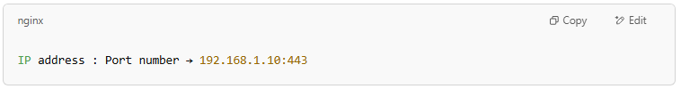
IP address : Port number → 192.168.1.10:443

🧭 Common Port Numbers
# Source: AI Source: Provided by: [Data Path: Persons Table -> ID Column: 1, Name_En Column: Motasem Essam] -> From: [ChatGPT] on [1/18/2026]

Port | Protocol | Purpose
80 | HTTP | Web browsing (unencrypted)
443 | HTTPS | Web browsing (secure/TLS)
22 | SSH | Secure remote access
25 | SMTP | Sending emails (unencrypted)
587 | SMTP w/ TLS | Sending emails (secure)
993 | IMAP w/ SSL | Reading emails (secure)
995 | POP3 w/ SSL | Downloading emails (secure)
21 | FTP | File Transfer Protocol
3306 | MySQL | MySQL database access

🔐 Types of Ports
# Source: AI Source: Provided by: [Data Path: Persons Table -> ID Column: 1, Name_En Column: Motasem Essam] -> From: [ChatGPT] on [1/18/2026]

Range | Use
0–1023 | Well-known ports (reserved for standard services)
1024–49151 | Registered ports (for user or vendor apps)
49152–65535 | Dynamic/private ports (used temporarily by clients)

✅ Summary
# Source: AI Source: Provided by: [Data Path: Persons Table -> ID Column: 1, Name_En Column: Motasem Essam] -> From: [ChatGPT] on [1/18/2026]

Port = Software channel that lets a computer talk to a specific service
🏠 IP address = Computer’s address🚪 Port = Service’s door
🔐 Use correct ports + encryption for secure communication

2-Socket
# Source: AI Source: Provided by: [Data Path: Persons Table -> ID Column: 1, Name_En Column: Motasem Essam] -> From: [ChatGPT] on [1/18/2026]
A socket is a combination of:
- An IP address (identifies the computer or device)
- A port number (identifies the specific service or application)
Together, a socket allows two devices to establish a connection and exchange data over a network.

🧠 Think of It Like This:
# Source: AI Source: Provided by: [Data Path: Persons Table -> ID Column: 1, Name_En Column: Motasem Essam] -> From: [ChatGPT] on [1/18/2026]
🔌 A socket is like a phone line that connects two people:
- The IP address is the phone number
- The port is the extension for a specific department
- The socket is the full connection between both ends

🔹 Technical Definition
# Source: AI Source: Provided by: [Data Path: Persons Table -> ID Column: 1, Name_En Column: Motasem Essam] -> From: [ChatGPT] on [1/18/2026]
A socket is an endpoint in a two-way communication link between two programs running on the network.
It’s defined as:
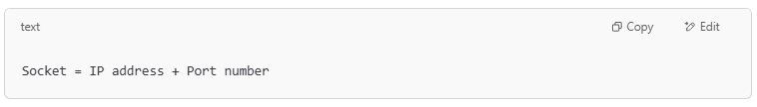
Socket = IP address + Port number

Example:
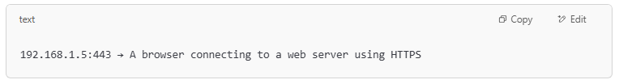
192.168.1.5:443 → A browser connecting to a web server using HTTPS

🔄 Types of Sockets
# Source: AI Source: Provided by: [Data Path: Persons Table -> ID Column: 1, Name_En Column: Motasem Essam] -> From: [ChatGPT] on [1/18/2026]

Socket Type | Description | Common Use
Stream Socket | Reliable, uses TCP (Transmission Control Protocol) | Web, email, file transfer
Datagram Socket | Unreliable, uses UDP (User Datagram Protocol) | Video streaming, gaming

🛠️ How Sockets Work (Simple Flow)
# Source: AI Source: Provided by: [Data Path: Persons Table -> ID Column: 1, Name_En Column: Motasem Essam] -> From: [ChatGPT] on [1/18/2026]
- Server opens a socket and waits for connections (listens on a port)
- Client opens its own socket and connects to the server's socket
- Data flows back and forth through these connected sockets

🔧 Socket Example in Python
# Source: AI Source: Provided by: [Data Path: Persons Table -> ID Column: 1, Name_En Column: Motasem Essam] -> From: [ChatGPT] on [1/18/2026]
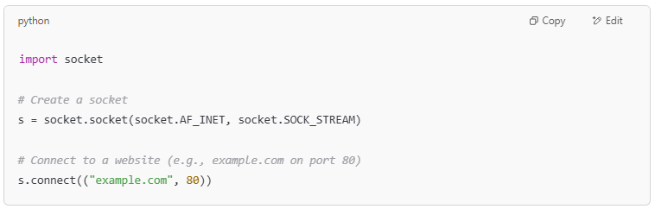
import socket

# Create a socket
s = socket.socket(socket.AF_INET, socket.SOCK_STREAM)

# Connect to a website (e.g., example.com on port 80)
s.connect(("example.com", 80))

✅ Summary
# Source: AI Source: Provided by: [Data Path: Persons Table -> ID Column: 1, Name_En Column: Motasem Essam] -> From: [ChatGPT] on [1/18/2026]

Socket = IP + Port = Endpoint for communication
🖥️ Used in nearly all internet and network connections
🔌 Enables devices and apps to talk to each other
💬 Essential for protocols like TCP, UDP, HTTP, SMTP, etc.

